Internet of Things Using Pet Food Feeder
Description:
WeMos D1 Mini is a powerful internet-enabled development board. This small development board uses one of the most popular and cost-effective Wi-Fi microchip ESP8266, making it a perfect choice for any beginner-level internet of things projects.
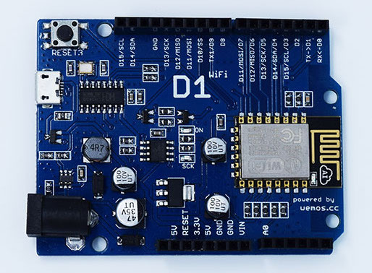

WiFi ESP8266 Development Board WEMOS D1. WEMOS D1 is a WIFI development board based on ESP8266 12E. The functioning is similar to that of NODEMCU, except that the hardware is built resembling Arduino UNO. The D1 board can be configured to work on Arduino environment using BOARDS MANAGER.
Specification:
- Microcontroller: ESP-8266EX
- Operating Voltage: 3.3V
- Digital I/O Pins: 11
- Analog Input Pins: 1
- Clock Speed: 80MHz/160MHz
- Flash: 4M bytes

Requirments:
WiFi ESP8266 Development Board WEMOS D1
SG90 Servo Motor
3D Model for Dispenser

Circuit Diagram

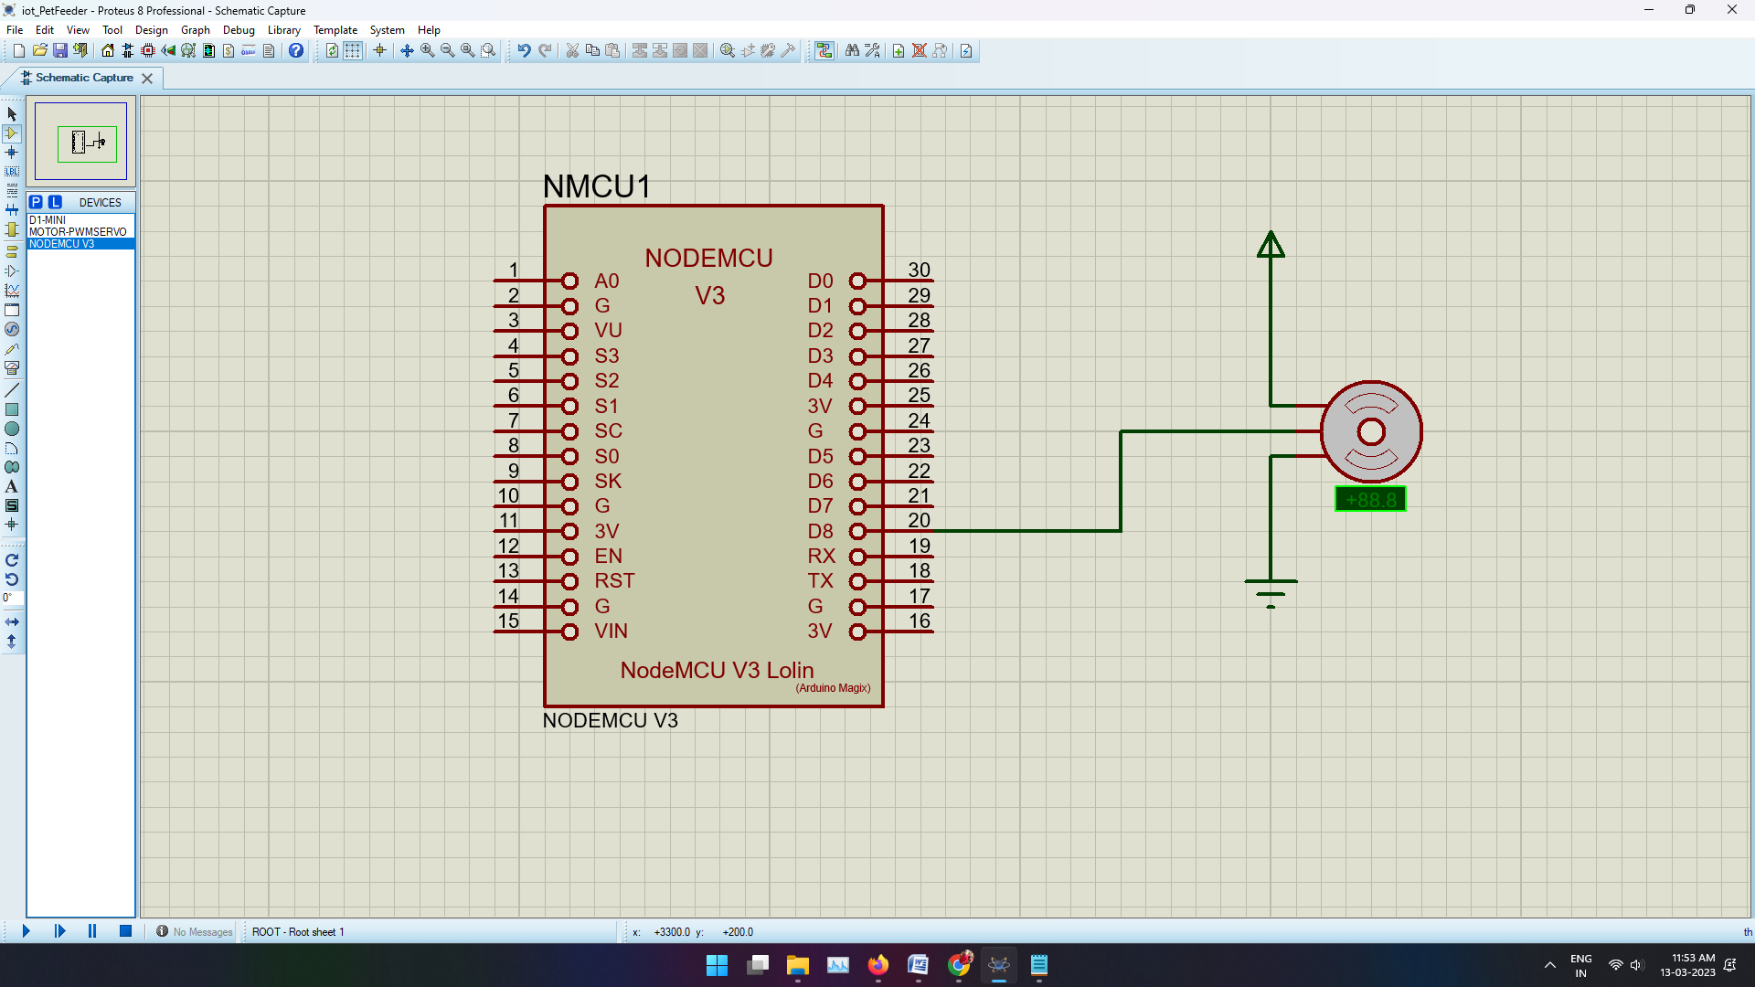

Program:
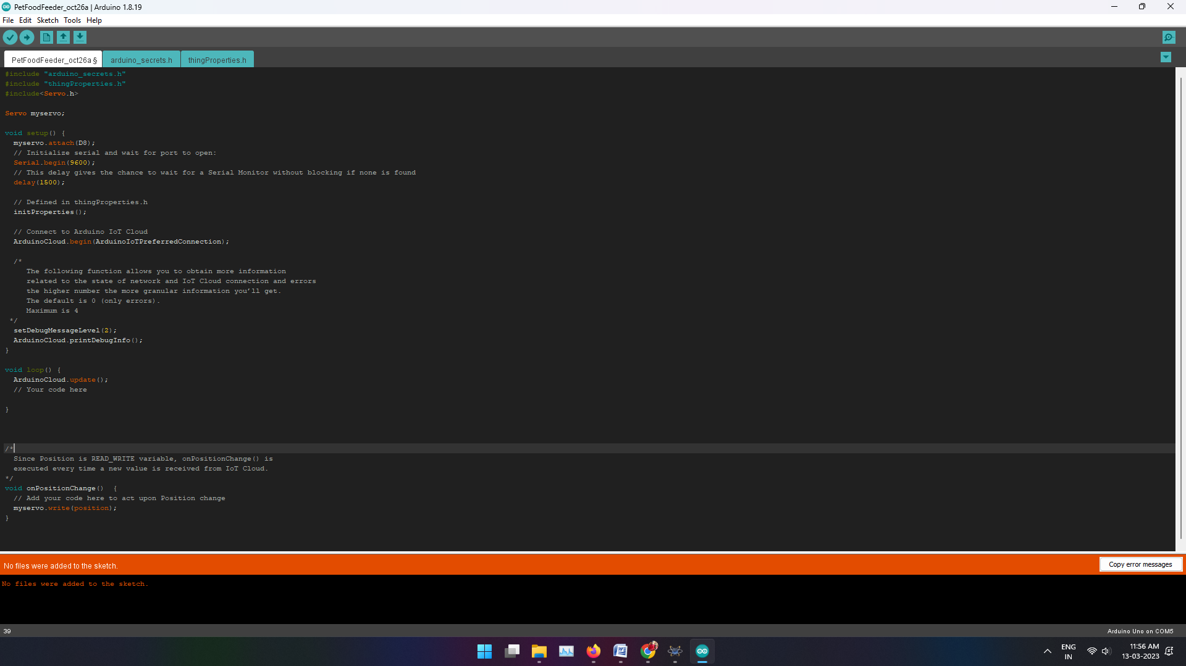
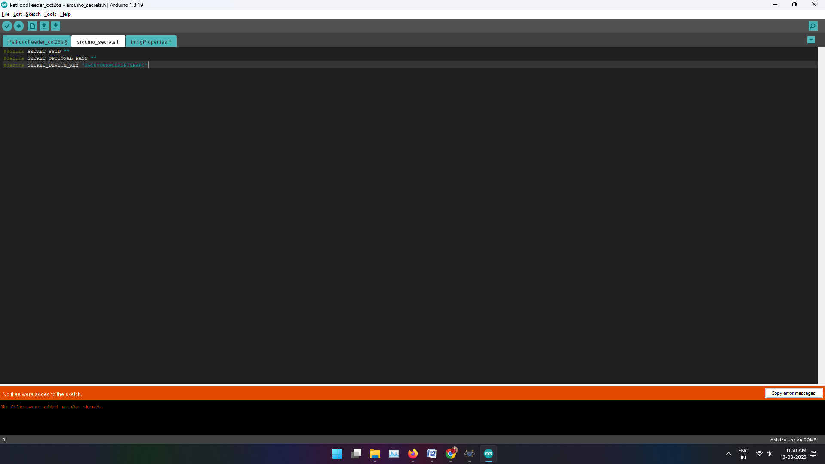

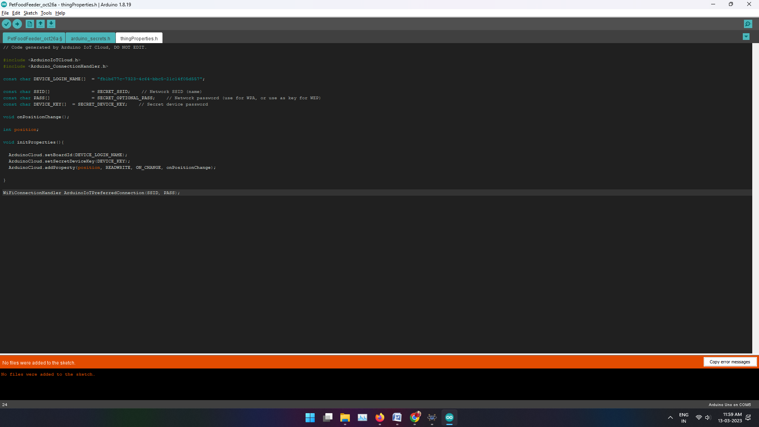
Conclusion:
Overall, we have gained familiarity with the WeMos D1 Mini and Arduino IoT Cloud Remote IoT platform using the Arduino IDE, and ended up with an awesome IoT Pet Feeder to show for it!

